BORDERLINE MEETINGS
On the second Saturday of the month
Start 9.30am NSW time at
Engine Driver’s Barracks
Tenterfield Railway Museum,
Tenterfield
Access for members via West Lane
Members are encouraged to bring something they are working on or a fun technique to share after meetings.
Contacts:
President- Liz Powell 043424652
Vice- President – Gay Landeta 0418795135
Secretary - Sue Jurd 0459468433
Treasurer - Sheryl Wright 0447919614
Please email your completed form to
membersborderline@gmail.com
NB: Allowance can be made for new members joining part the way through the year. Contact President or Treasurer. Membership forms and Payments must be received before the AGM on the second Saturday in September to be eligible to vote.

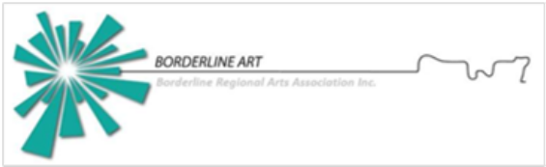
Borderline Arts has members from both sides of the Queensland and NSW border.
‘Borderline’ is a community based non-profit organisation which aims to encourage artistic expression, creative development, and interaction with other artists. We run workshops, group exhibitions, social gatherings and provide networking opportunities, information on exhibitions, competitions, prizes, sales outlets, festivals, and access to the Borderline web site members pages. Members span a wide range of media and art practices and include the novice to the more experienced.

See more about Borderline at borderlineregionalarts.com.au

BORDERLINE REGIONAL ARTS
ASSOCIATION
Membership
Date……………………………………….
Membership runs for financial year
1st July to 31st June
Please print details
Name……………………………………………………………….
Address………………………………………………………………
Phone………………………………………………………………..
Email………………………………………………………………….
Fees: $35 per single membership
$50 per couple

Signature…………………………………………Date…………
Payment Options:
postal The Treasurer,
PO Box 201,Tenterfield, NSW 2372 OR
Direct Debit to BSB 062605
Acc. No. 10150042
Include your surname and Mbshp as reference

